**By:Harsha Vardhan Chokkakula (harsha.chokkakula@wipro.com)**

**Mentors:  Gayathri Nelavigi**

**ONLINE DIET MANAGEMENT PROGRAMME**

**ONLINE DIET MANAGEMENT PROGRAMME**

**Introduction:**  
Diet Program is an Online-based public service program, which helps people in maintaining their diet by taking help from experts. This application consists of several groups classified based on the BMI (above 25 and below 25). In each group, relevant tips and plans will be shared on how to maintain a healthy diet.  
  
**End-users:**

This application classifies users into 3 types. They are Admin, Motivator and Challengers. Here Admin is the main root user, who can perform all actions. Such as Posting in group, Approving and Rejecting user requests, Promoting users and Removing users, Views daily log and Monthly Measurements entered by the challenger. Whereas Motivator is someone who was once a user, now promoted as motivator who can also perform certain actions in that particular group. Messages, Links and Files regarding Tips and Diet Plans will be posted in appropriate group by Admin/Moderators, where challengers from that group can make use of it.

**Technologies/Tools used:**   
  
1. **Frontend** : Angular 8  
  
2. **Backend** : Java 8 ( Springboot )  
  
3. **Database** : In-memory H2 database

4. **IDE** : Visual Studio Code (Frontend) and Spring Tool Suite (Backend)

**Database Structure:**

1. **Credentials** :

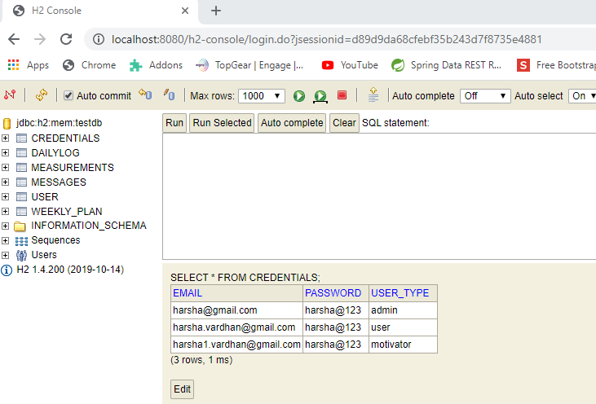

1. **DailyLog:**

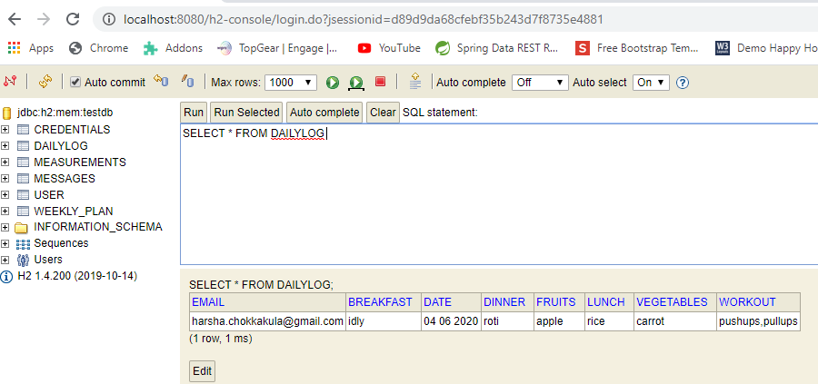

3**.Measurements:**

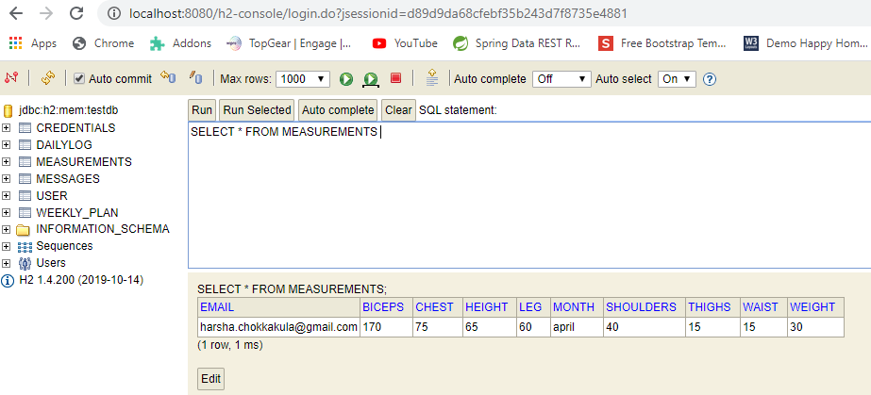

4.**Messages :**

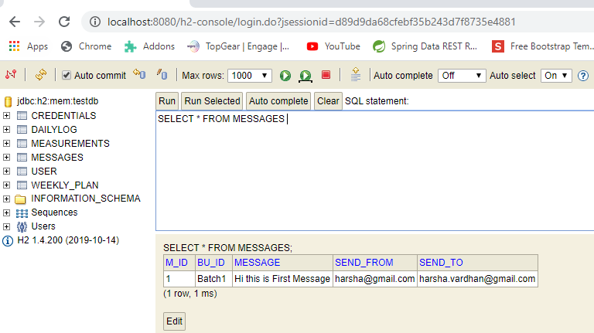

5**.User:**

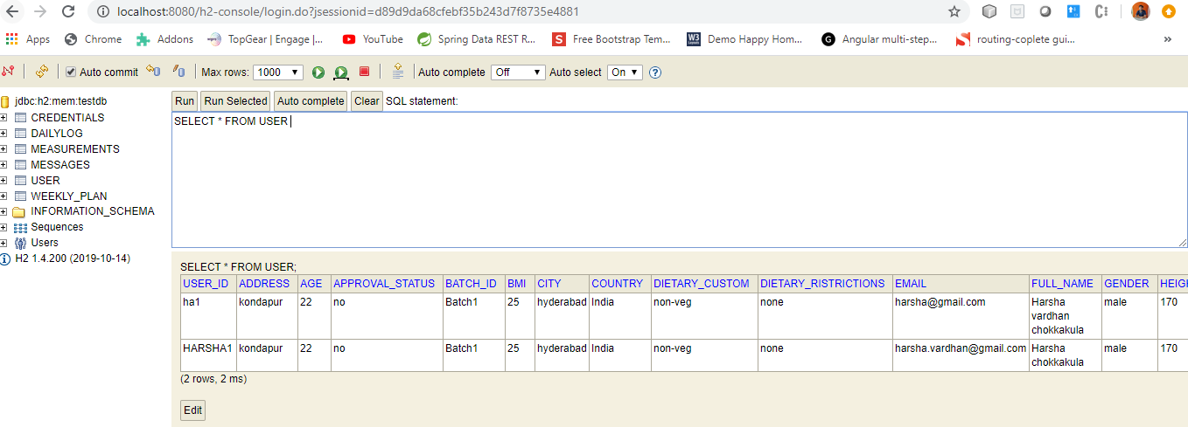

6**.WeeklyPlan :**

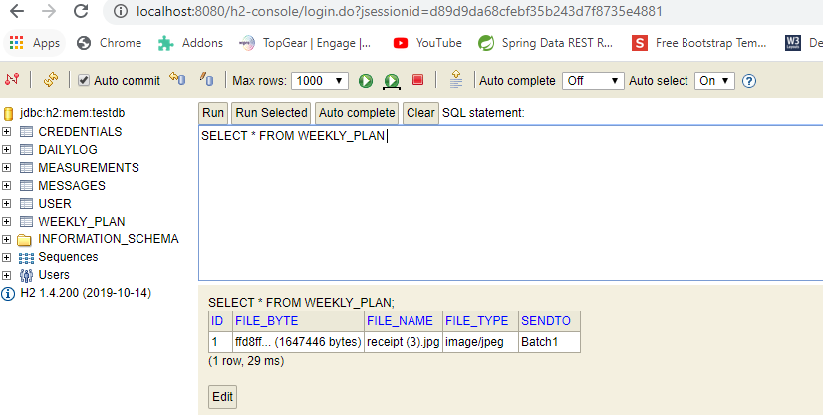

**UI Screenshots :**

1. **Login Page** :

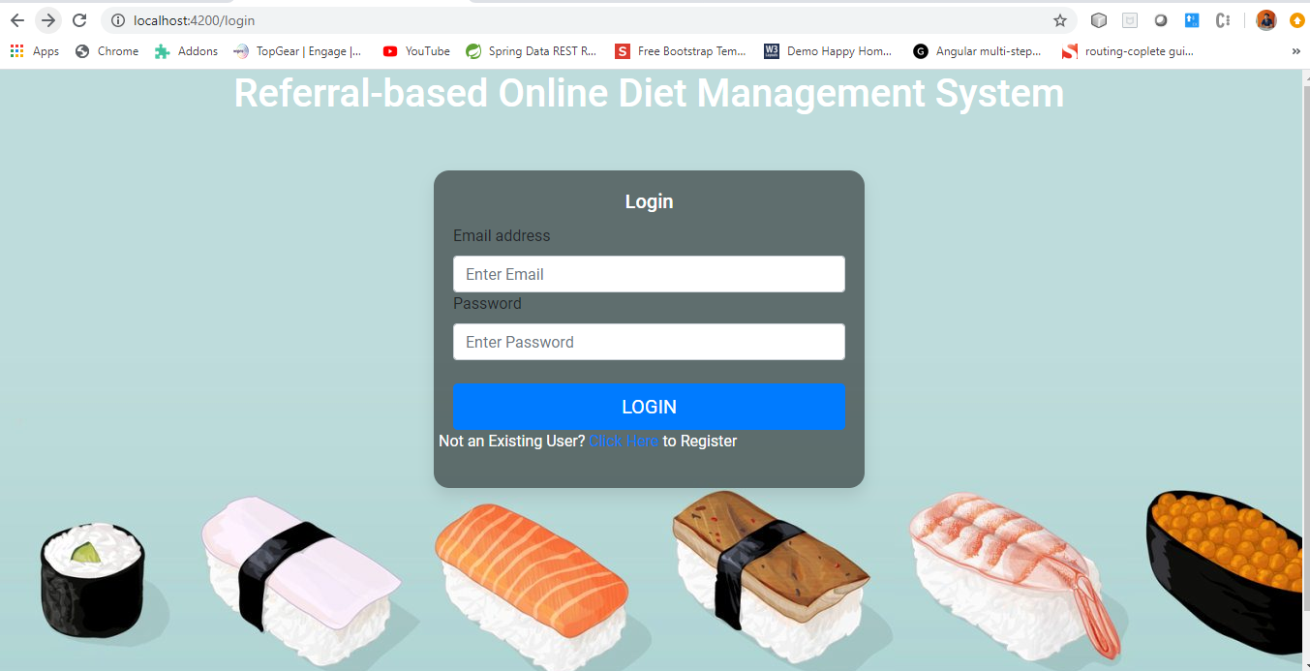

2. **Invalid Password Page** :

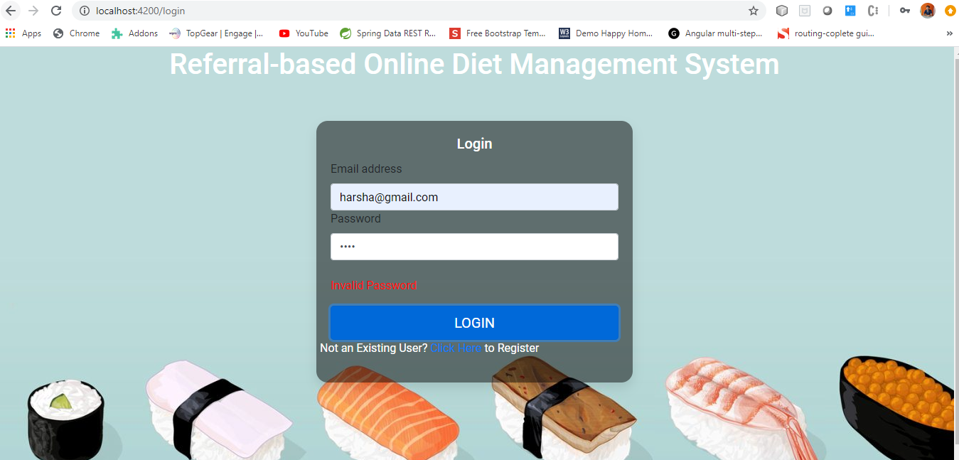

3. **Invalid User Page** :

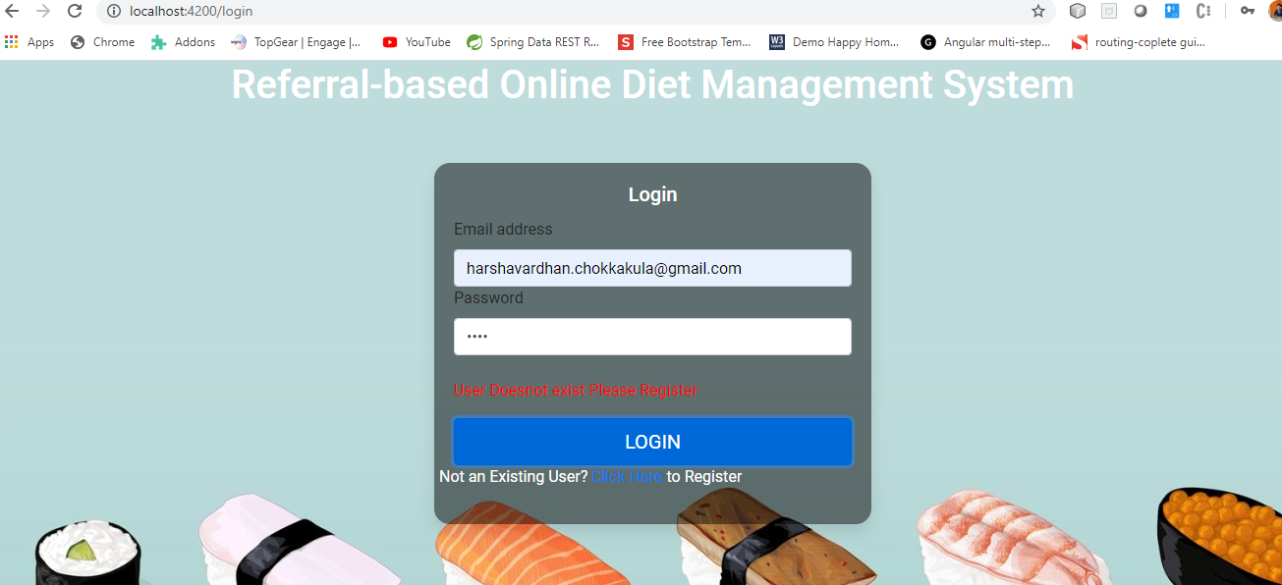

**6.Registration:**

**Pregnancy status will display only when user select gender as female. Also if the user has referral code After entering the code system will verify whether it is valid or not and if not valid an error message will display. Because this is Referral based dietary management System.**

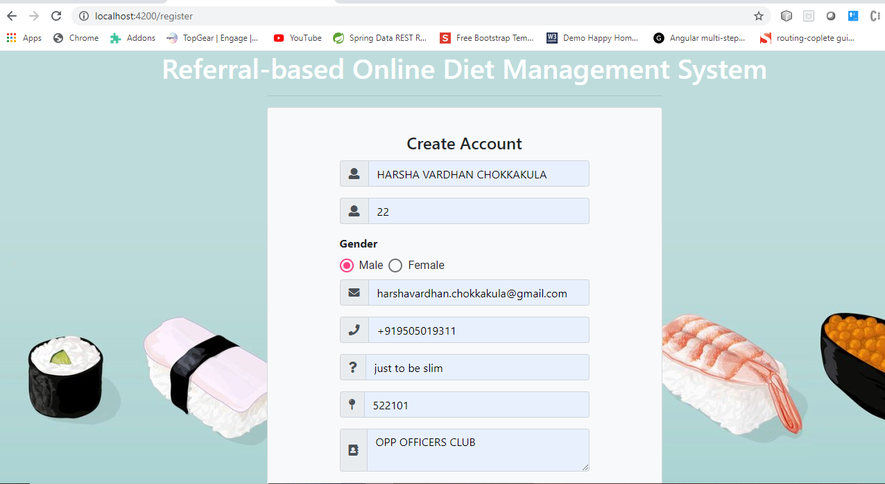

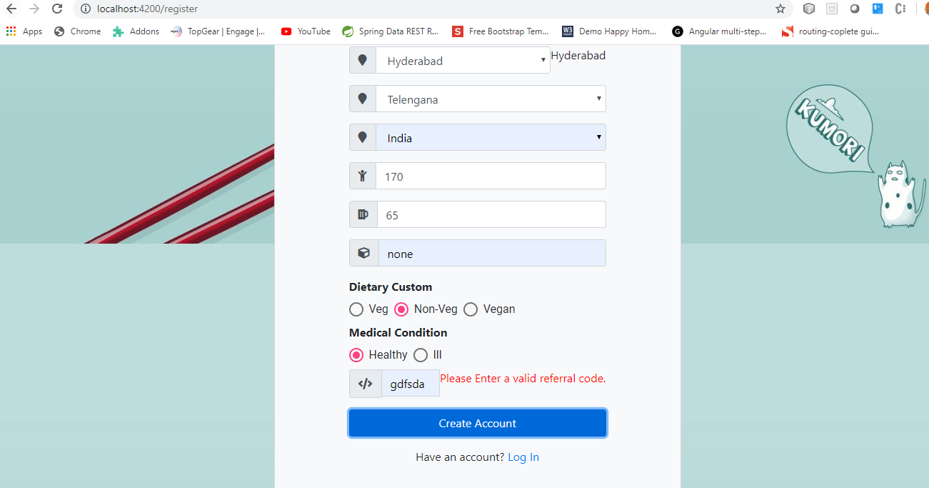

**If the user is successfully added then we’ll show a message to the challenger along with name.**

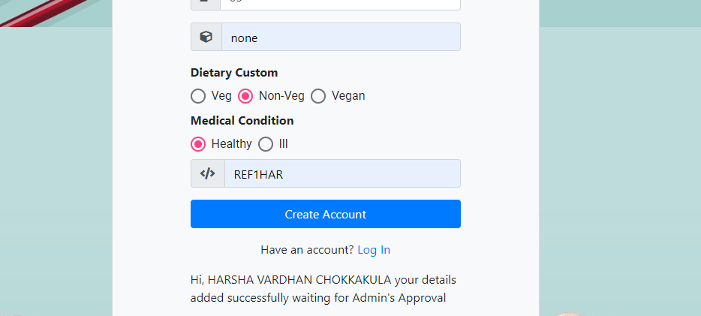

**5:Admin**

**5.1 Admin home**

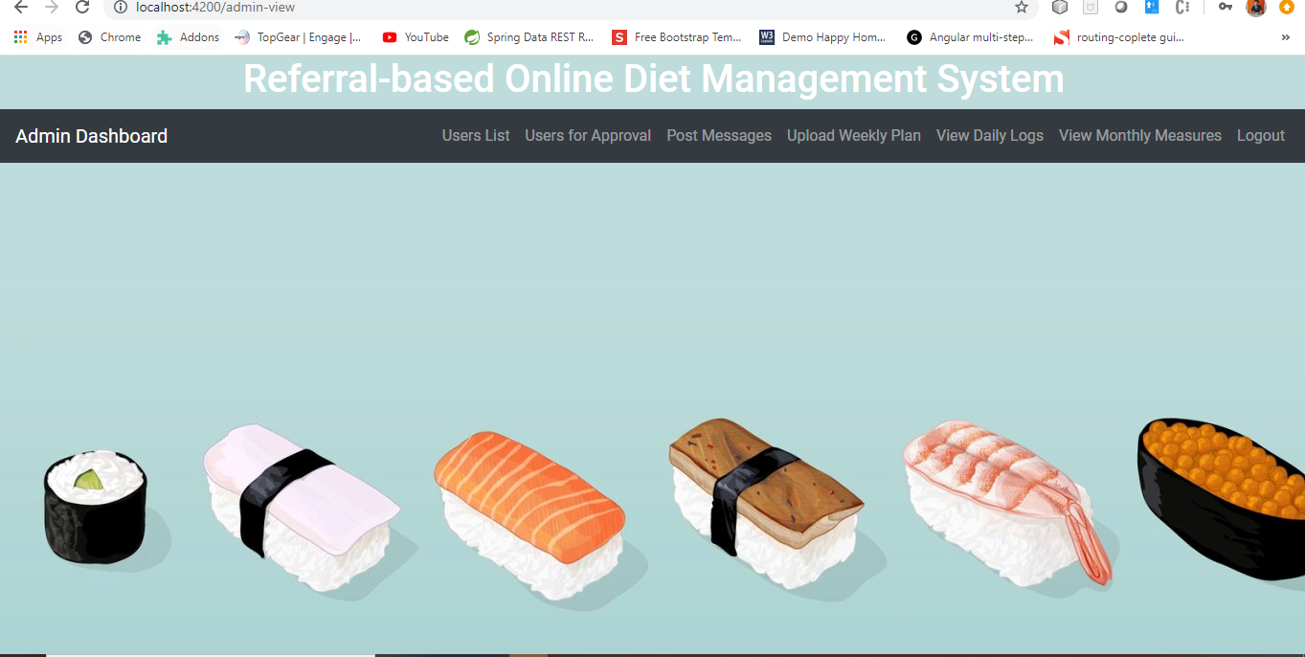

**5.2:Users List**

**Here Admin can view list of users. And admin can search users based on UserId or BatchNo.**

**5.2.1: Show all Users**

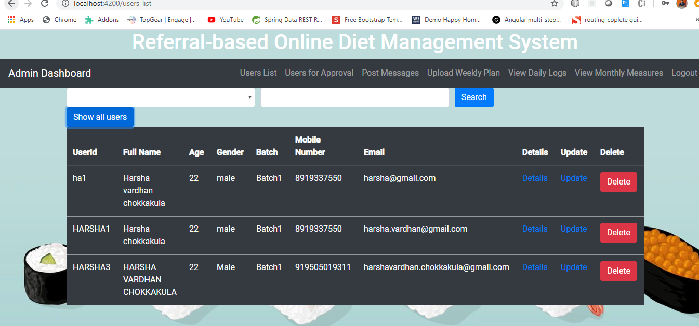

**5.2.2: Users By BatchNo**

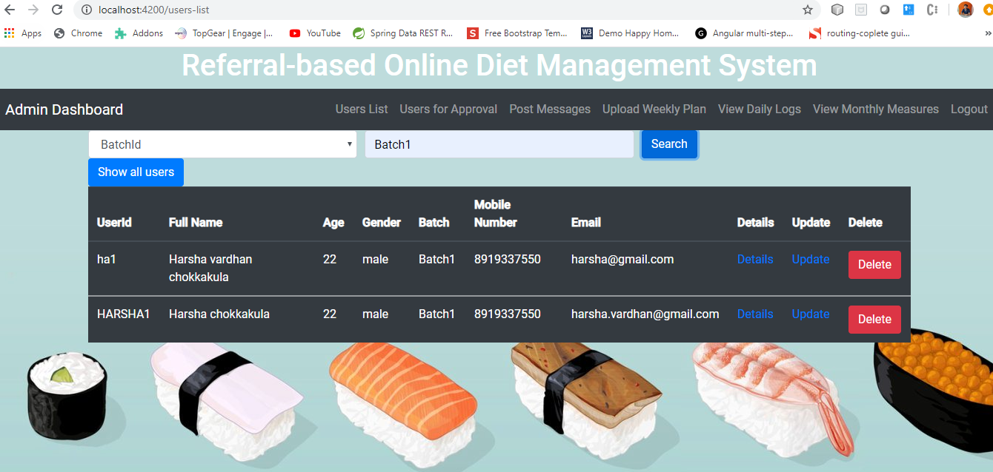

**5.2.3: User By UserId**

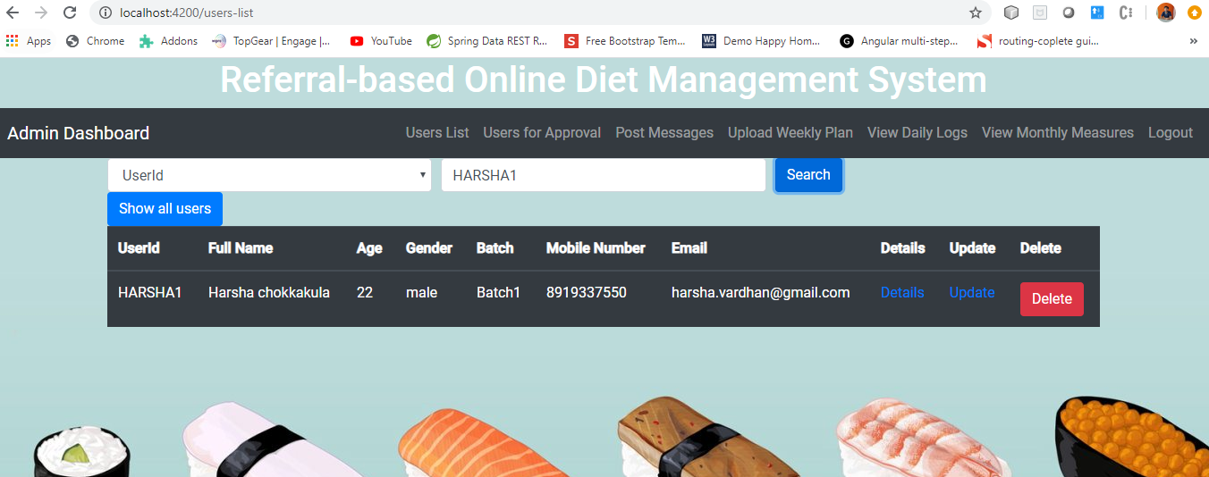**5.2.4: Details of Particular User:**

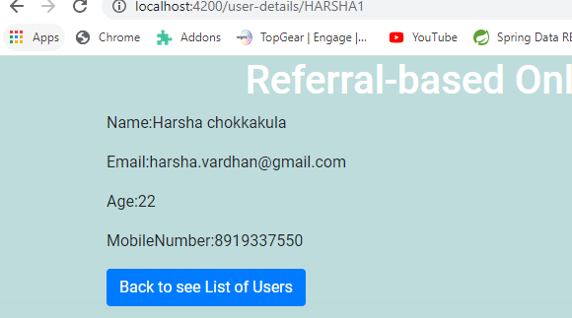

**5.2.5: Updating details of User:**

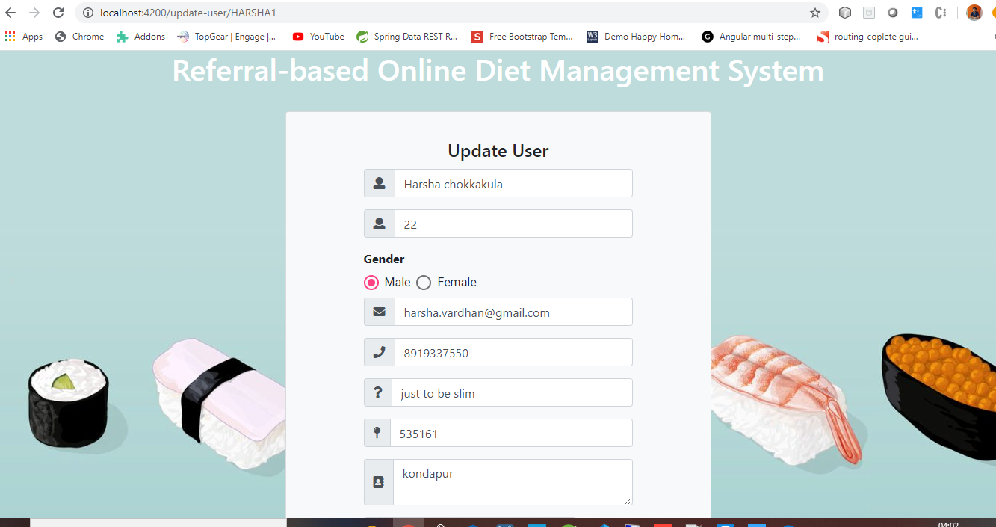

**5.2.6: Delete User**

**After deleting user component will automatically gets reloaded and will show new list of users.**

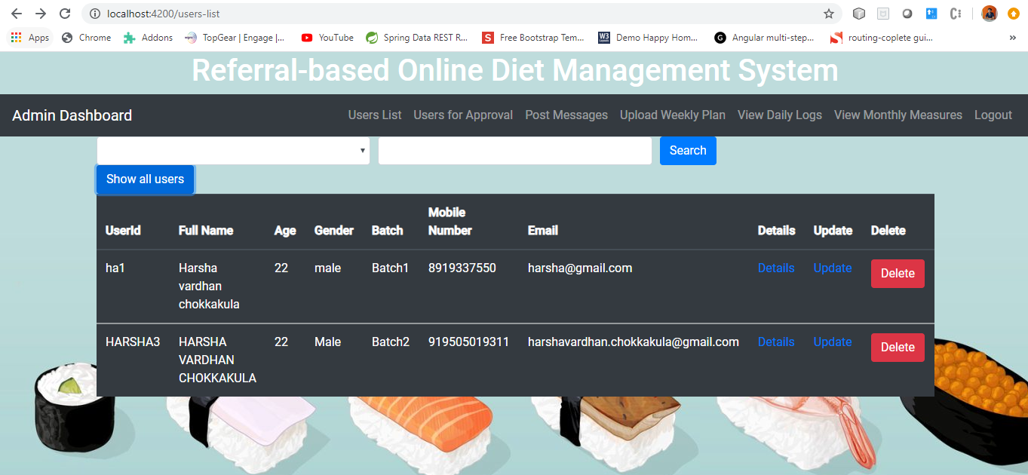

**5.3:Users for Approval**

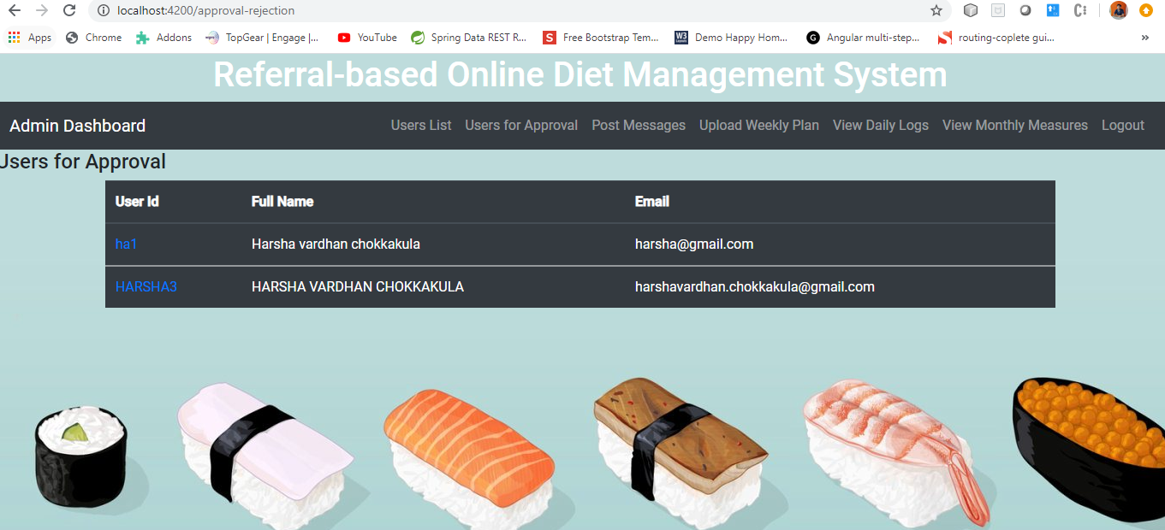

**After clicking on a particular UserId we’ll navigate to a page where all details of user will be shown along with approve or reject buttons.**

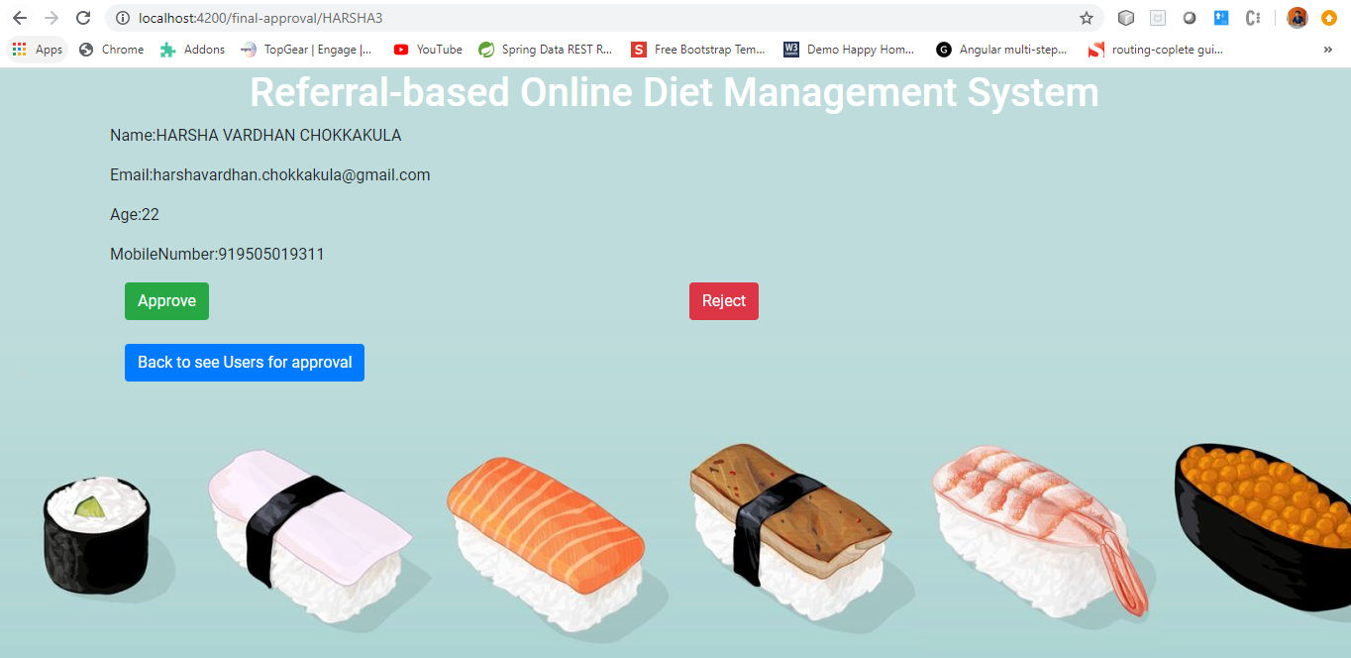

**After clicking on Approve or Reject we’ll get appropriate mail with Congratulations or Sorry message.**

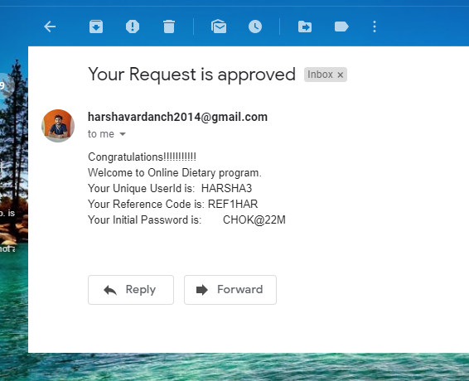

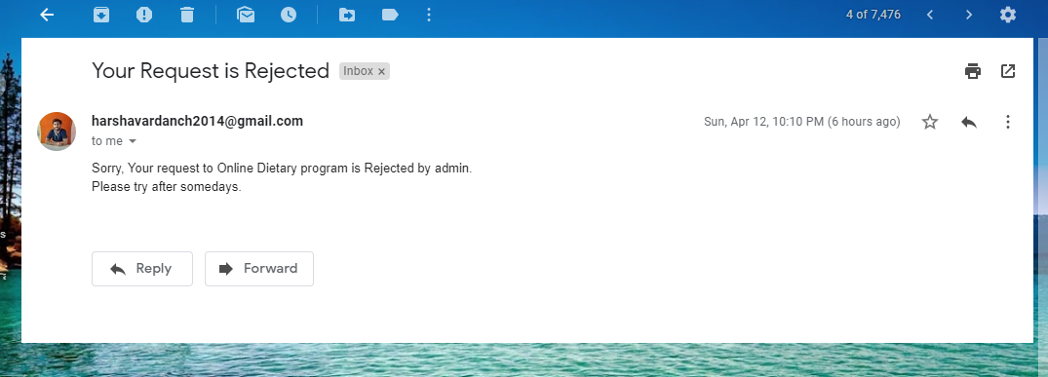

**5.4:Post Messages**

**Admin can post messages to motivator or Individual User or All Users of a particular Batch.**

**If User or Motivator then have to enter mail id and if the selected one is batch, then textbox will be disabled automatically.**

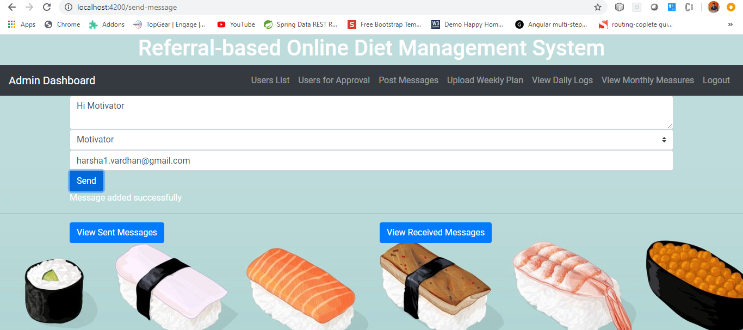

**Admin will able to view the messages which the admin sent and view the messages admin got.**

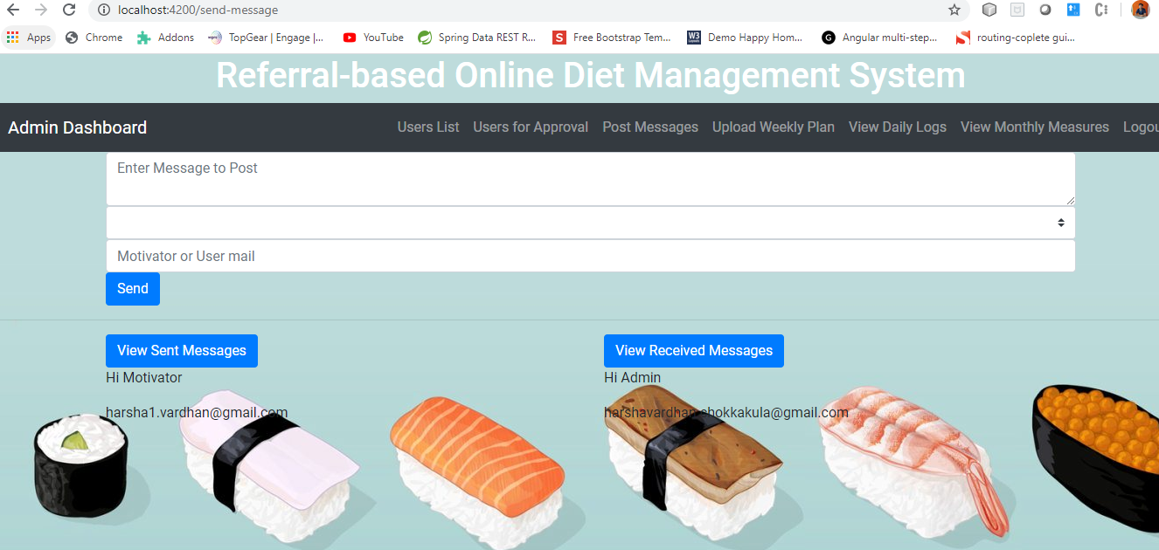

**5.5: Upload Weekly Plan**

**Admin can able to upload weekly diet or workout plan to the challengers based on batch.**

**And can be able to view all the uploaded files by clicking on show files button.**

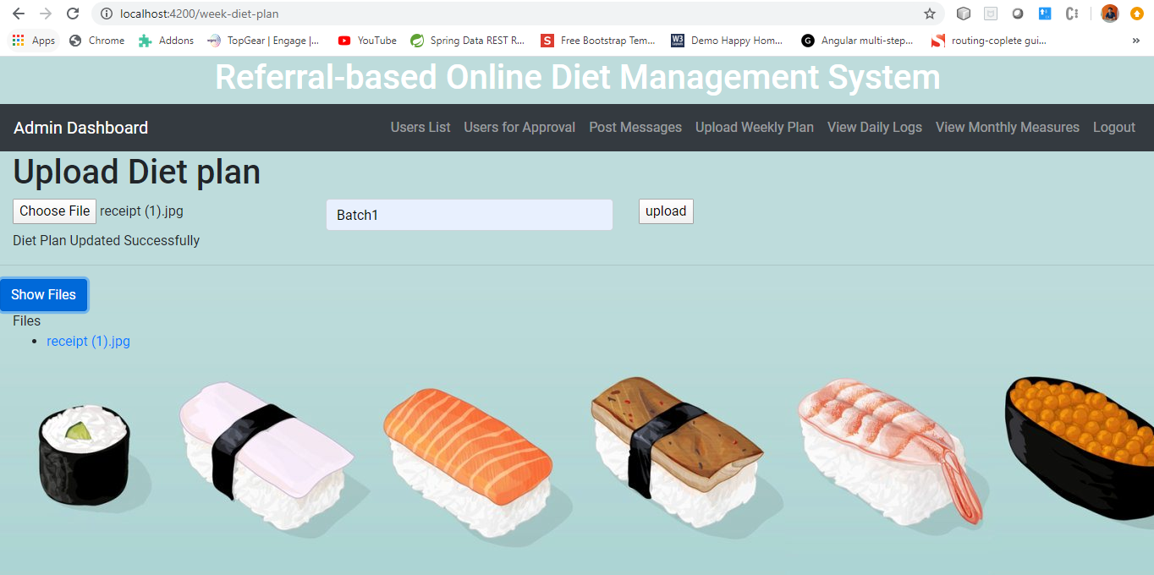

**5.6 View Daily Logs**

**Admin can able to view all the daily logs which are updated by Challengers along with Date.**

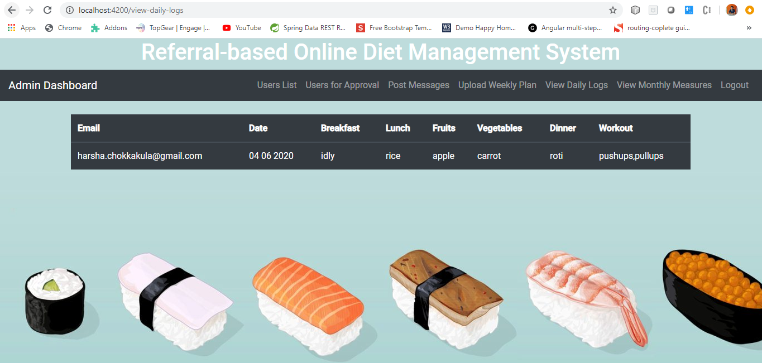

**5.7: View Monthly Measures**

**Admin can able to view all the Monthly Measurements which are updated by Challengers along with Month.**

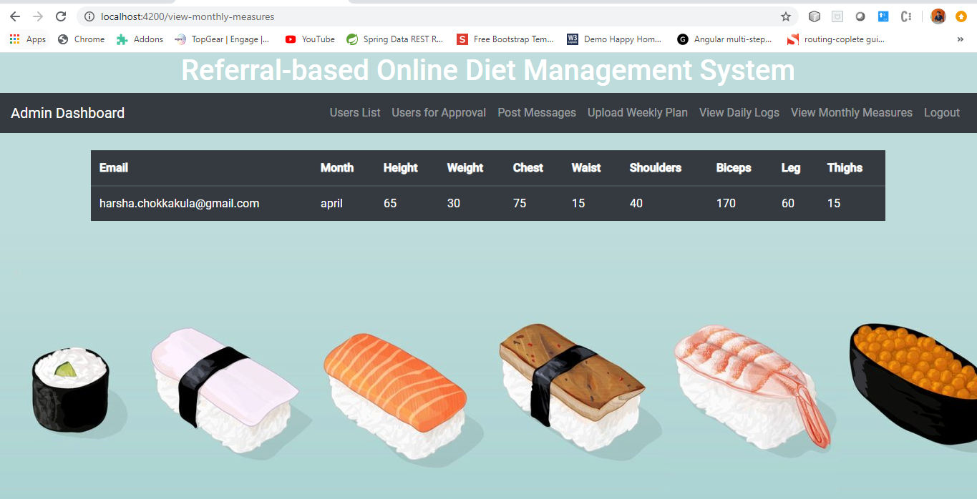

1. **Motivator**

**6.1: Motivator Home**

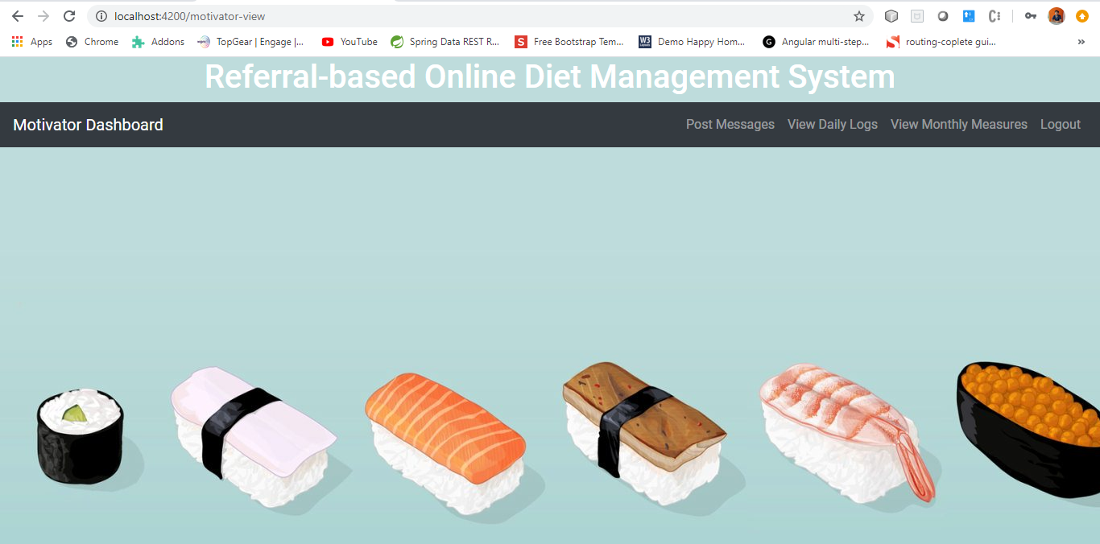

**6.2: Post Messages**

**Motivator can post messages to Admin or Individual User by entering mail id**

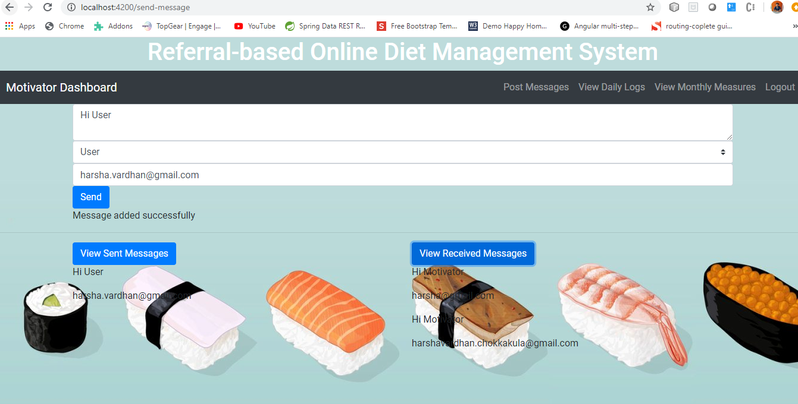

**6.3: View Daily Logs**

**Motivator can able to view all the daily logs which are updated by Challengers along with Date.**

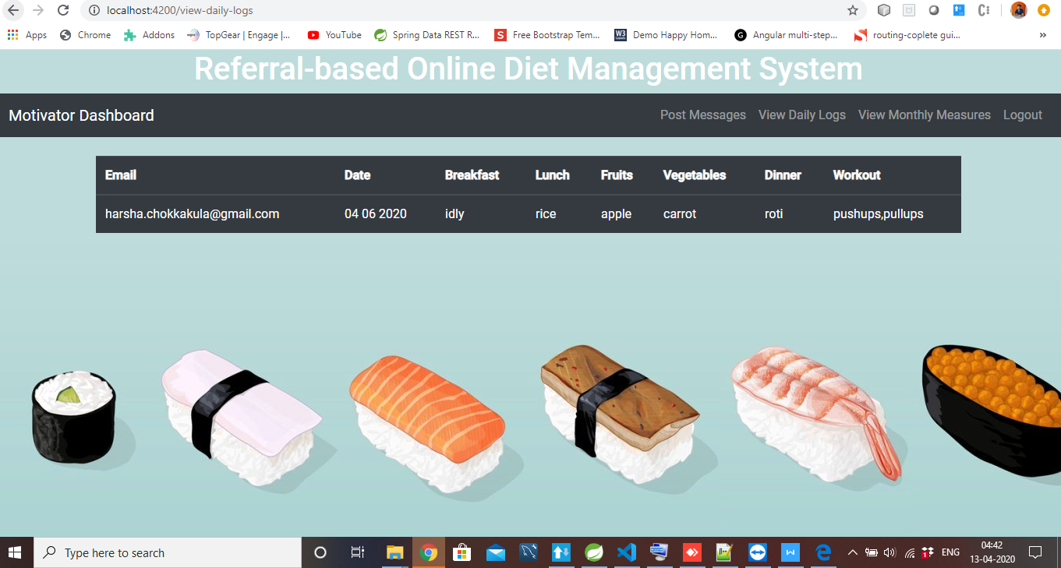

**6.4: View Monthly Measures**

**Motivator can able to view all the Monthly Measurements which are updated by Challengers along with Month.**

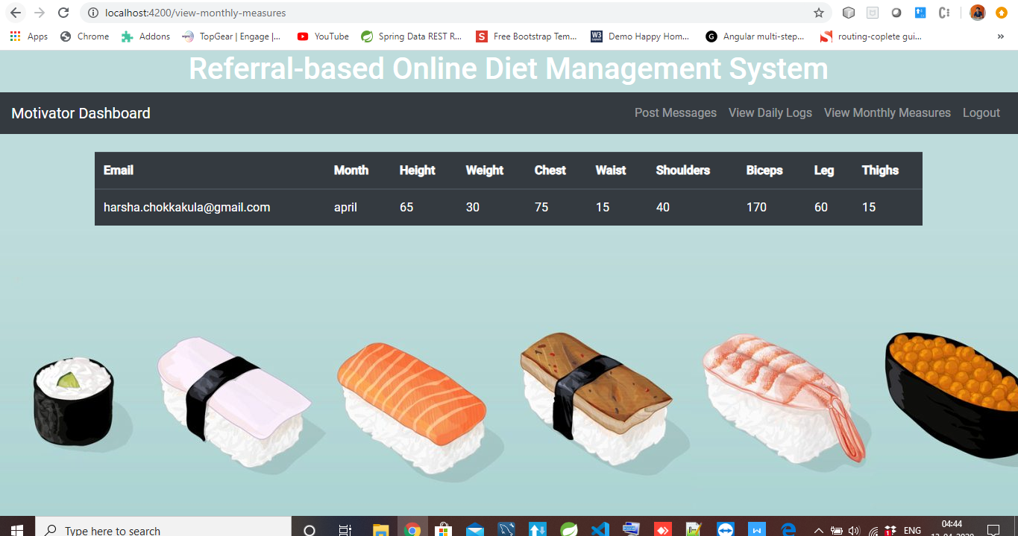

1. **Challengers**

**7.1: Challenger Home**

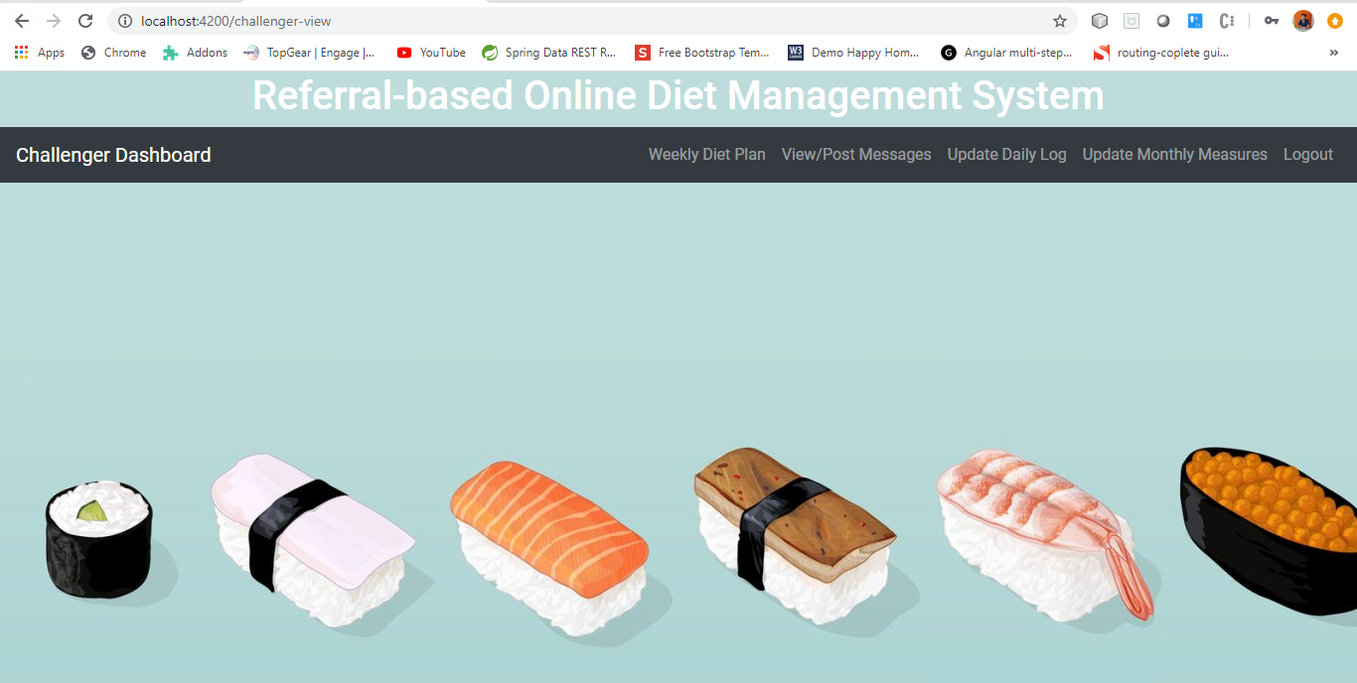

**7.2: Weekly Diet Plan**

**Challenger can be able to download the file uploaded by admin based on the challenger’s batch**

**On clicking on that file it’ll be downloaded automatically.**

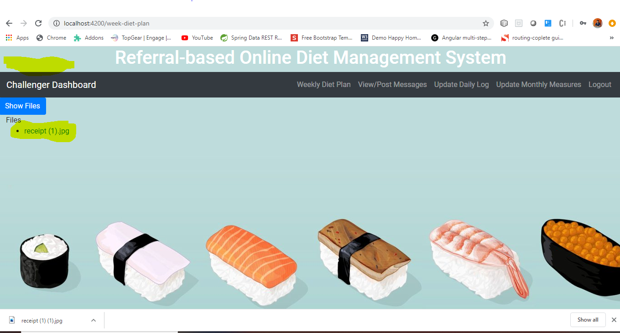

**7.3: Post messages:**

**Challenger can be able to post message to admin or motivator using email id.**

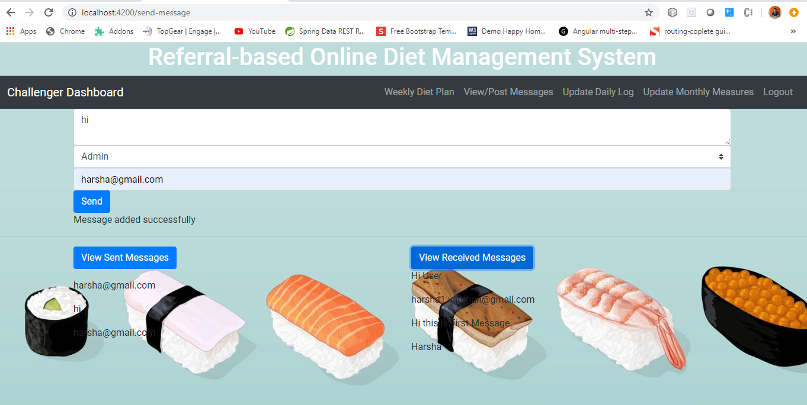

**7.4: Update Daily Log**

**Challenger can be able update daily log.**

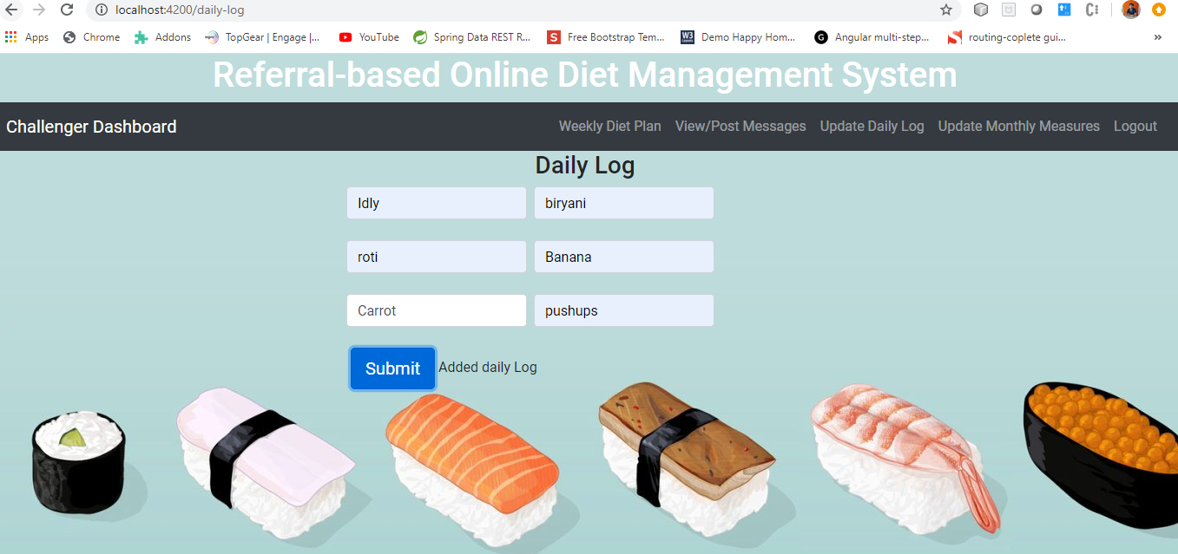

**7.5: Update Monthly Measurements**



**Future Enhancements :**

* One-on-One chat Facility (Like Admin/Moderator can message/share tips to a particular user alone in a private space).
* Graph should be displayed which contains progress of their diet plan. So one can easily understand the status and plan it accordingly
* User sending their response back to every activity, whether they have done it or not.
* Social Login like Facebook, twitter
* Implement login based on JWT token based Authentication.
* UI/UX Changes (More Animations).
* Easy accessing table data by using Syncfusion library for handling table data.

THANK YOU………………!!!